Data Convergence ∙Consumer Research Expert
ConsumerInsight Report
Company | ConsumerInsight |  | E-mail | kimmh@consumerinsight.kr
Query | Kim, Minhwa Director |  | Contact | 02) 6004-7643
Issued | Thursday, April. 25th 2024 |  | Pages | Total of 7 pages

Top Value-For-Money
Overseas Travel Destinations for Koreans
ConsumerInsight compares Overseas Travel Costs and
Satisfaction by Country in 2023
- Japan and Thailand offer "Low Cost, High Satisfaction" making them the top value-for-money destinations... Next is Australia
- France, USA, and Hawaii are perceived as "High Cost, Low Satisfaction," indicating low value-for-money
- Decent travel destinations: Switzerland, Italy, and New Zealand, with 'High-Cost, High-Satisfaction'
- Asia’s average satisfaction is equivalent to top Korean destinations, like Busan and Gangwon
- Strong preference in Asia is attributed to the low value-for-money of destinations in Korea
○ In the assessment of ‘Value-for-money’ (Cost-effectiveness) among overseas travel destinations, Japan and Thailand emerged as the most superior, while France and the USA fell short. These results are based on the cost per day and satisfaction levels of the top 27 most visited overseas destinations.
□ The travel research firm ConsumerInsight conducts an annual satisfaction study on overseas travel destinations every September. The firm inquire 9,375 respondents who have traveled abroad in the past 1 year (from September 2022 to August 2023) how satisfied they were with their destination and whether they would recommend it to others. The firm get the overall satisfaction score (out of 1000 points) for 27 countries with a sample size of over 60 respondents each. The average daily cost for each country is also determined. By comparing the rankings of satisfaction and cost, destinations with significantly higher satisfaction rankings are considered excellent in terms of cost-effectiveness, while those with lower rankings are deemed inadequate.

■ Satisfaction with value-for-money in overseas destinations: Japan, Thailand stand out in Asia
○ The top value-for-money destinations for "low-cost & high-satisfaction" were Japan and Thailand. Japan (ranked 20th in travel cost and 6th in satisfaction) and Thailand (ranked 26th in cost and 12th in satisfaction) had the highest value-for-money index (+14) among 27 countries [Figure, Table]. Following them were Australia (+8), Indonesia (+8), Vietnam (+8), and Spain (+7) in that order.
□ For convenience, a value-for-money index (C) was created by comparing (A-B) the rankings of daily travel expenses (A) and travel satisfaction (B). When there's a positive difference between rankings based on travel cost (higher cost ranked first) and satisfaction (higher satisfaction ranked first), it indicates 'high value-for-money,' whereas a negative difference suggests 'low value-for-money'.

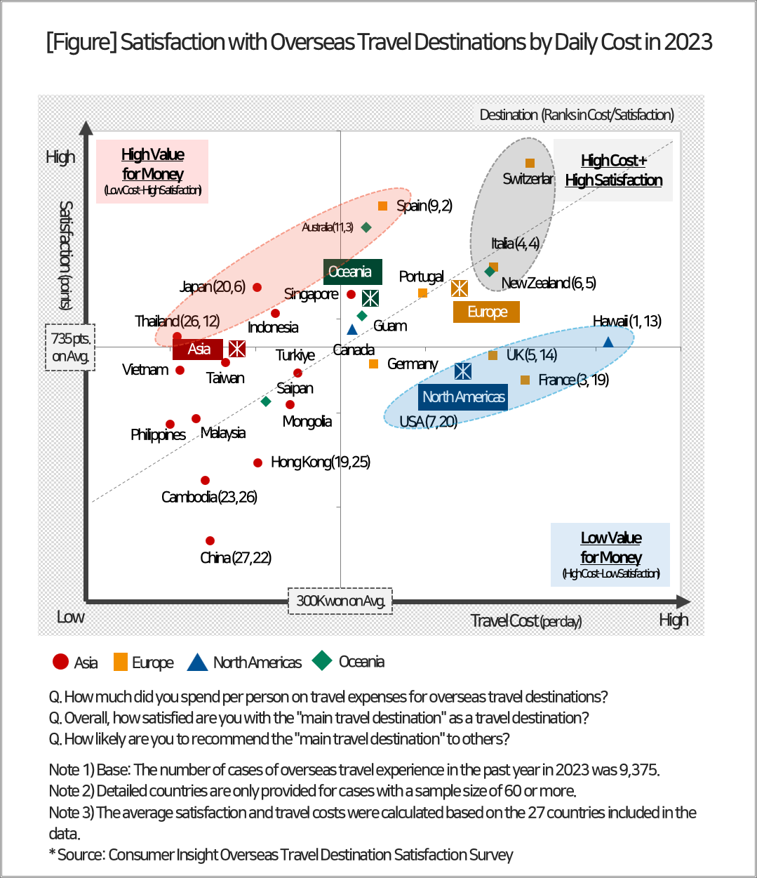

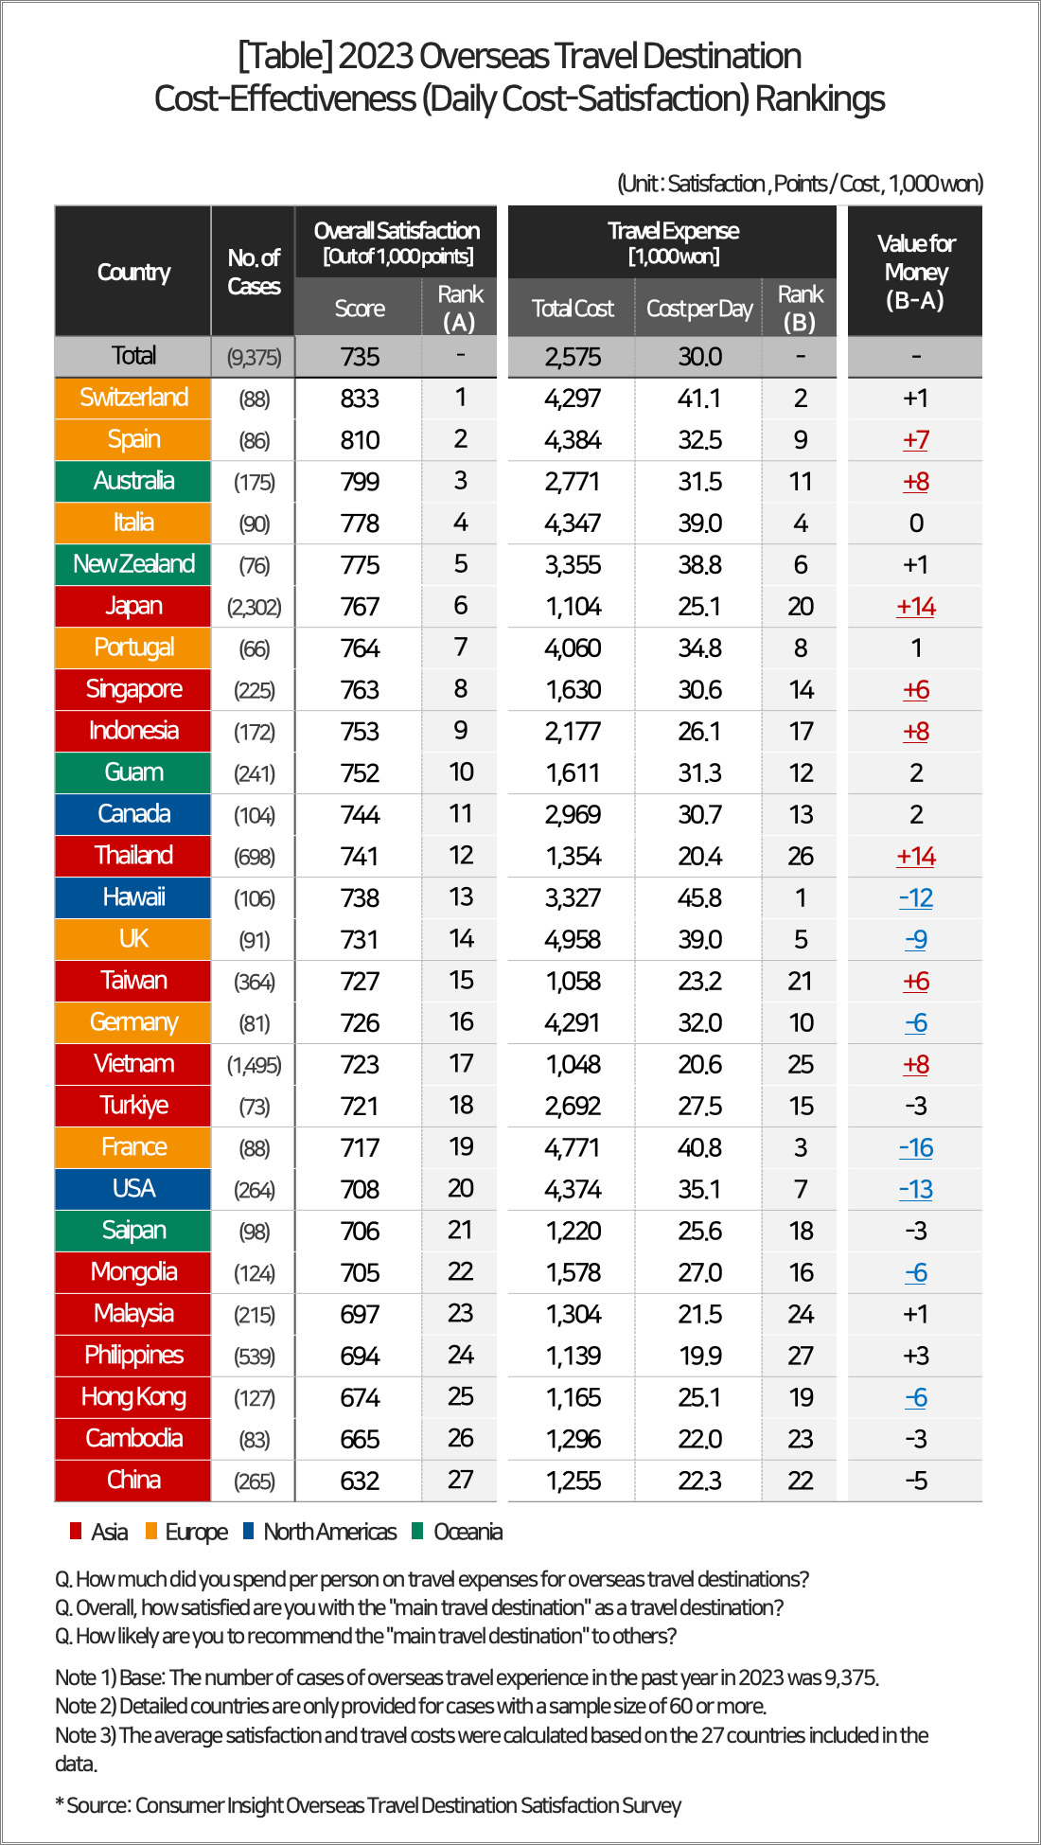
○ Typical examples of destinations with unsatisfactory value-for-money in terms of "high cost & low satisfaction" include France (-16), followed by the United States (-13), Hawaii (-12), and the United Kingdom (-9). The daily travel expenses in these countries ranged from 350,000 to 450,000 won on average, placing them at the top level (1st to 7th) in terms of ‘high expenses.’ However, the satisfaction level remained relatively low, ranking in the middle to lower range (13th to 20th).
○ The top destinations for "high cost & high satisfaction" were Switzerland, Italy, and New Zealand, in that order. These countries ranked at the highest level for both travel expenses and satisfaction, with minimal differences between them (ranking 2nd and 1st for cost and satisfaction, 4th/4th, and 6th/5th respectively).

■ Overseas travel cost : Total cost of 2.57 million won on average... 300K won per day
○ The average total travel expense for overseas travelers was 2.575 million won, approximately equivalent to 300K won per day. By continent, travelers spent the most in Europe with an average of 4.444 million won, followed by North America (3.557 million won), Oceania (2.239 million won), and Asia (1.446 million won), showing significant regional differences. Traveling Europe, known for its high cost and longer duration, exceeds the total expenses of the most affordable Asian destinations by more than three times.
○ When converted to a daily rate, ‘Hawaii’ topped the list as the most expensive destination, averaging 458,000 won per day, followed by Switzerland (411K won), France (408K won), and Italy and the UK (both at 390K won), primarily comprising European countries. This is due to the high cost of airfare, dining, and accommodation, which are significantly higher than in Asian countries. On the other hand, the Philippines was the lowest at 199K won, followed by Thailand, Vietnam, and Malaysia, all in the early 200K won range.

■ Asia's average travel satisfaction, at 734 points, exceeds domestic travel
○ Overseas travel is rapidly recovering as pent-up demand is being unleashed. Given the contrasting trends of economic downturn and the surge in overseas travel, it's expected that there will be a rise in the preference for value-for-money, highly satisfying destinations in Asia in the future.
○ Among the Asian travel destinations commonly visited by Koreans, the daily travel expenses for Japan, Vietnam, Thailand, and the Philippines are approximately 200K won, while for the domestic travel destination Jeju Island, which is known for being the most costly in Korea, it's around 132K won. This means that traveling to Asian countries is possible at a cost about only 1.5 times higher than traveling to Jeju.
○ In terms of traveler satisfaction as well, Asia has surpassed Korean domestic travel destinations. The average satisfaction score for Korean travelers in Asia is 734 points, nearly matching the satisfaction levels of the top two domestic travel destinations: Busan at 736 points and Gangwon at 735 points. Meanwhile, it surpasses the satisfaction levels of Jeonnam, ranked third at 724 points, and Jeju, ranked fourth at 723 points, by more than 10 points. Compared to the high satisfaction levels of Japan (767 points) and Singapore (763 points), the countries with the highest value-for-money in overseas travel, the lag of Korean domestic travel destinations is concerning. Unless improvements are made to the value-for-money of domestic travel, there is a possibility that the trend of shifting towards overseas travel will further intensify.

ConsumerInsight provides professional and scientific research services across various industries such as automotive, telecommunications, shopping/distribution, tourism, and finance, utilizing a large-scale online panel that is efficient for non-face-to-face surveys. We enhance the value of data by integrating panel research data with various big data sources, focusing on applying it to various industries. Particularly, we recently launched the "KD-Panel," a survey platform with a 100% mobile-based approach and nationwide representativeness, which is open for use by anyone in the research industry.
This report is based on the "Annual Overseas Travel and Travel Product Satisfaction Survey," conducted by the ConsumerInsight Consumer Trends Research Institute, which targets over 25,000 travel consumers every September. The survey results and analysis reports, updated annually, can be viewed at https://www.consumerinsight.co.kr/eleisure-travel/index, where summaries of the survey results from 2016 to 2022 are also available for download. (Download Report)
---------------------------------------------------------------------------------------------------------------------
Copyright ⓒ Consumer Insight. All rights reserved. The copyright of this material belongs to ConsumerInsight, and it cannot be used for commercial purposes other than reporting.
For-more-Information
Kim, Minhwa Research Director/Ph.D | kimmh@consumerinsight.kr | 02)6004-7643
Lee, Jesung Chief Researcher/Ph.D | leejs@consumerinsight.kr | 02)6004-7631

